Linear/Matrix Algebra

Planar Antenna Array for the MQ-9 Predator Unmanned Aerial Vehicle (UAV)

Author: Team MCCCXXXVII

Team: MCCCXXXVII

Team Leader: Michael P. Doran

Team Members:

Carlos J. Lazo

Carolyn M. Andrews

Colin D. Fischer

Michael P. Doran

Course: Linear Matrix Algebra

Instructor: Duane A. Beaulieu

Group Hours:

Date Submitted: 10/6/2008

Executive Summary

Problem

Experts in the field of Electronic Warfare (EW) have identified a new radio that hostile forces are using to communicate in the battlefield. There is an urgent need to jam all communications from this radio in order to complete a high priority, top secret operation codenamed SANTA.

To jam the radio signal, our high performance Integrated Project Team (IPT), Team MCCCXXXVII, has been asked to design a planar antenna array composed of Commercial Off The Shelf (COTS) antennas and High Power Amplifiers (HPAs). This antenna array will be installed on an MQ-9 Predator Unmanned Aerial Vehicle (UAV).

The jammer beam must remain on the target for up to 20 minutes to support SANTA ground operations. SANTA Mission Planners have mapped out the Predators flight path to within 5 nautical miles of the immobile target.

Method of Analysis

We first determine the transmit signal power required to jam the radio signals. To do this, we must consider the worst case, when the UAV is at its furthest from the target. Based on this distance, signal attenuation through the atmosphere, and the power required to jam a receiver, we can determine the amount of power we must transmit.

We also determine the beam width necessary to cover the 5 nautical mile target zone from our altitude. This provides us the knowledge required to determine the overall dimensions of our antenna array.

We then are able to choose COTS components that will work for this application. We also consider size, weight, and power consumption, as we are constrained by the limits of the Predator UAV.

We will perform all mathematical analysis using MATLAB and mechanical design using Pro-E.

Results / Recommendations

We have determined that the planar antenna array described in our results section will meet or exceed all requirements for this mission. It is recommended that the antenna array be developed immediately so that Operation SANTA can be executed successfully.

Table of Contents

Executive Summary 2
Problem 2
Method of Analysis 2
Results / Recommendations 2
Problem Statement 4
Overview 4
System Description 4
Assumptions 4
System Analysis 7
Approach 7
Detailed Analysis 7
Results 11
Results 11
References 12
Appendix A – Trade Study 13
Appendix B – Mechanical Drawings 14
Appendix C – Performance Plots 15

List of Figures

Figure 1 - Example Plot of Beam Pattern 10

List of Tables

Table 1 - Antenna Beam Pattern Cases 9

Nomenclature

Symbol | Definition | Units
f | Frequency | GHz
λ | Wavelength | Meters (m)
D | Length of Antenna Array | m
d_{x}, d_{y} | Distance between antenna elements in a given direction | m
n_{x}, n_{y} | Number of antenna elements in a given direction | ----
R_{bw}, R_{i} | Radial Distance | m
c | Speed of light | Meters/Second (m/s)

Problem Statement

Overview

The experts in the field of Electronic Warfare have determined that hostile forces are using a new type of radio for communication. There is an urgent need to jam this signal to support a top secret operation codenamed SANTA. Ground forces require enemy communications to be inoperable for up to 20 minutes in order to complete their task.

Our high performance IPT, Team MCCCXXXVII, has been tasked with designing a planar antenna array from COTS antennas and HPAs capable of targeting the radio with a jamming beam. This antenna array will be installed on an MQ-9 Predator UAV.

SANTA Mission Planners have determined the location of the target to within 5 nautical miles. The UAV will be required to fly directly over the target area, jamming the area for 20 minutes.

System Description

The enemy radio operates in the 3.5GHz and 5.8GHz bands (IEEE Radar Bands S and C) using right hand circular polarization from omni-directional antennas. The maximum output power of the radio is an estimated 50W. From this, we estimate that the receivers in the region have a sensitivity of -80 dBm.

The target radio will exist in a target area within a 5 nautical miles of the ground trace of the Predators flight path. In order to complete the operation, the receiver will need to be jammed for up to 20 minutes.

The system architect has allocated 150 lbs and 10 kW to the planar antenna array on the UAV. Mounting locations exist under the wings of the UAV. Based on our assumptions, we have a total potential area of 9.35 meters by 2.75 meters in which to place our antenna.

Assumptions

- The MQ-9 Predator UAV is the US Air Force Version with the following specifications.
  - Length: 11m
  - Fuselage Width: 1.3m
  - Wingspan: 20m
  - Wing Area: 23.78 sq. m
  - Cruise Speed: 160 km/h
  - Max Speed: 400 km/h
  - Op. Alt.: 25000 ft
  - Ceiling: 50000 ft
  - The aircraft power is either 28V DC or 3Φ 120V AC
    - The aircraft power can be converted to a usable power very efficiently at little cost impact
  - This provides us with estimates of the altitude and speed of the UAV for use in our calculations
  - This provides us with estimates to use in the mechanical design of the system
- Wing depth is 2.715 m
- This is based on wing area and wingspan. It provides us estimates to use in the mechanical design of the system
- We are able to work with COTS suppliers to repackage components to fit our spatial requirements as well as meet environmental requirements. Our group utilizes the MIL-STD-810 series of standards to specify various environmental conditions that the COTS components will encounter in the field.
  - Operating Temperature Range: -55ºC to 85ºC as described by MIL-STD-810F
  - Operational Altitude: Sea Level to 50,000ft as described by MIL-STD-810F
  - Will operate in vibration profile for MQ-9 as described by MIL-STD-810F
  - Will operate in environment with a relative humidity of 0% to 100%
  - Will operate in a sand or dust environment described by MIL-STD-810F
  - Will not be damaged by any flight line fluids
  - Will not be made up of any hazardous materials
  - Will be made with materials that discourage fungal growth
  - Will survive a dripping rain test described by MIL-STD-810F
- This allows us to neglect antenna and HPA dimensions when determining element spacing.
- This allows us to neglect environmental limits of components.
- The UAV’s flight path is a straight line directly over the center of the target area.
- This simplifies the geometrical analysis of the system
- A signal 5 dB greater than the target receivers sensitivity will be sufficient to jam radio transmissions
- This provides us with a goal on which to base our jammers output power
- Receiver sensitivity is estimated to be -80 dBm.
- This is based on typical receiver sensitivities and provides us a basis to estimate required power.
- The addition of the antenna array will not cause the aircraft to weaken structurally
- This is based on typical aircraft integration requirements for both the military and the Federal Aviation Administration (FAA)
- The aircraft will function normally with the addition of 150 lb to the underside of the right aircraft wing
- This allows us to assume the aircraft will be able to compensate for the slight shift in center of mass
- By placing the antenna array on the underside of the wing it is assumed there will be minimal aerodynamic effect on the operation of the aircraft
- This allows us to neglect the aerodynamic impact of our antenna array
- The antenna array will be structurally substantiated to survive a 9g emergency landing.
- This is based on typical aircraft integration requirements for the military
- A 1 kilometer band is wide enough to cover the target jamming area
- This allows us to focus our energy on an area and lowers our power requirements

System Analysis

Approach

We begin our analysis by looking two points along the flight path. First, we consider the point where we are furthest from the target, at time t=0. At this point, we suffer the most attenuation due to signal propagation through the air. Based on the distance from this point to the target, and the required power at the target, we can determine the amount of power we must transmit to jam the radio.

The second point to consider is when we are directly above our target, at time t=10 minutes. This is the point where our beam covers the least area because it does not have as much distance to spread over. We can use the geometry of the system here to determine the necessary dimensions of our antenna array.

Once we determine the dimensions of our array, we can adjust element spacing until we find a reasonable beam pattern for all required frequencies and steering angles. We can then use our spacing and signal strength requirements to select COTS antennas and HPAs which will meet the weight and power requirements.

Detailed Analysis

We begin our analysis by determining the maximum distance between our Predator UAV and the target during the jamming period. Since we planned our route so that the UAV will follow a straight flight path at constant altitude and pass over the target in the middle of the jamming period, the maximum distance occurs at the very beginning, t=0.

At this point, the UAV is 10 minutes away from the target, so we can determine the horizontal distance using the relationship between velocity and distance.

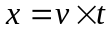 Equation 1

We can then solve for radial distance from the target based on horizontal distance and altitude of flight using the Pythagorean Theorem.

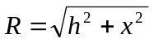 Equation 2

This distance R is the furthest our jammer will be from the target during the jamming period. This means that the signal will propagate over more distance, and thus attenuate by the greatest amount. We can solve for the attenuation in decibels over this distance using the Free Space Path Loss (FSPL) equation. We must use the highest frequency in our band for this calculation, as it will suffer the most loss.
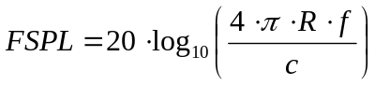 Equation 3

where R is the distance, f is signal frequency, and c is speed of light.

Since we know that the radio transmits a 50 watt signal (17 dB), we are estimating a receiver sensitivity of -80 dBm. We need to jam the receiver with 5 dB more than its sensitivity, so we must transmit enough power that -75 dB reaches the target. Using that value and the calculated attenuation, we can determine the required transmit power of our jammer.

We then look at the system when the UAV is directly over the center of the target area, when the distance from the jammer to the radio is at its minimum. At this point in time, the area being jammed will be at its smallest, because the signal spreads over a smaller distance. We can use system geometry to determine the beam width angle required from our antenna array.
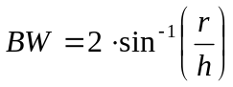 Equation 4
where r is the radius of the target area and h is the altitude

Using the antenna beamwidth equation, we can solve for the necessary dimensions of our antenna array. Here, we must use the smallest wavelength signal as that signal will result in the smallest beamwidth. Since our beam pattern is an ellipse, our array will be a rectangle, and we must solve for the necessary dimensions in both the x and y directions.
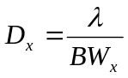 Equation 5
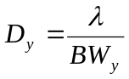 Equation 6
Where λ is the wavelength of the highest frequency signal and D is a dimension of our array.

The necessary overall dimension in the x and y directions controls the number of elements each respective direction.
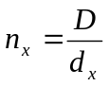 Equation 7
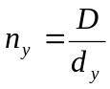 Equation 8
The spacing between each element, d_{x} or d_{y}, was specified by our team. The optimum spacing typically occurs when d_{x} or d_{y} is between λ/2 and λ. The spacing in each direction is optimized to obtain the minimum necessary elements while maintaining an appropriate beam pattern and antenna gain.

The antenna gain is calculated once the antenna array dimensions and components are known. The antenna gain is a function of number of elements in the array, the element spacing, and the wavelength the antenna array operates at.
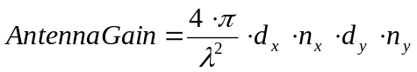 Equation 9
After the antenna gain is calculated we can determine our needs in a High Power Amplifier (HPA).
HPA Gain = Power at Receiver – Antenna Gain + FSPL Equation 10
The beam profile of the jamming signal has the ability to become a tapered beam by adjusting the power going to the different elements. In this problem we are using a uniform profile for the jamming signal beam. This means that each element of the antenna is receiving an equal amount of power.

We can calculate the wave number, k, of the of the antenna pattern for a given wavelength using equation 11.
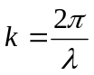 Equation 11
The signal is calculated and plotted. The signal pattern can be expressed by:
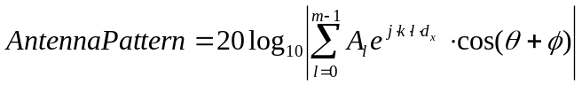 Equation 12
Where ф is the steering angle, θ is the angle of propagation, m is the number of elements, d is the distance between each element, and k is the wave number.

The signal is then plotted for a variety of cases. The cases can be seen in Table 1.

Table 1 - Antenna Beam Pattern Cases
Case | Frequency (GHz) | Steering Angle
1 | 3.5 | 0º
2 | 4.65 | 0 º
3 | 5.8 | 0 º
4 | 3.5 | 45 º
5 | 4.65 | 45 º
6 | 5.8 | 45 º

In addition to these plots two additional plots are included: a plot of antenna gain vs. frequency and beam width vs. frequency. The beam width plot shows that the beam width of the antenna will meet or exceed what is required at all frequencies in band. An example of the signal can be seen in Error: Reference source not found. Please refer to the Appendix for the additional plots.

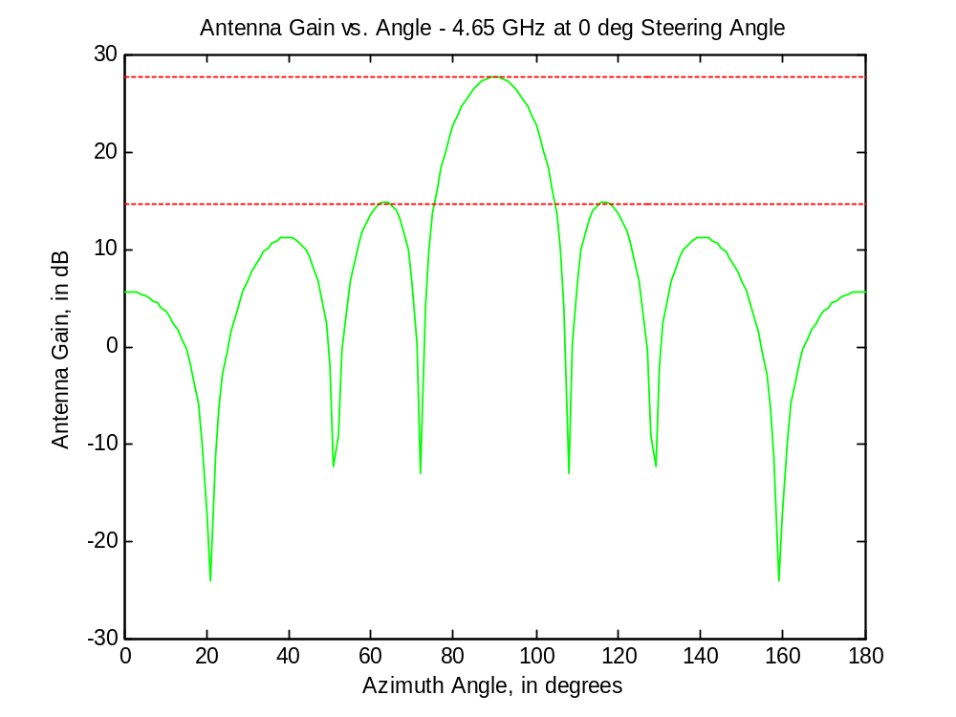
Figure 1 - Example Plot of Beam Pattern
The beam pattern plots show how power is distributed at different angles from the antenna array. The lobe with the highest amplitude is the main signal. The lobes surrounding the main signal are called side lobes or grating lobes. For the main signal to operate correctly the side lobes need to have a magnitude that is a minimum of 13 dB less than the amplitude of the main signal.

Results

Results

The Predator UAV flies at a cruising speed of 160 kilometers per hour and altitude of 7500 meters. At the furthest point from the target, we need to transmit 81.56 dBW from our antenna array in order to provide enough power to jam a receiver.

At the nearest point to the target, we need to ensure that we jam an area 10 nautical miles wide and 1 kilometer deep. We found that at our altitude, we need a beam width of 101.99 degrees by 15.19 degrees.

To meet this requirement, we found that an antenna array of 19.5 centimeters by 2.9 centimeters is sufficient.

We selected an element spacing in the long dimension of the signal wavelength divided by two in order to increase power. In the short dimension, we selected a spacing of wavelength over four to increase resolution. As a result, we have 2.586 centimeter spacing in the long dimension and 1.29 centimeter spacing in the short dimension. To obtain the correct antenna array size, we have a grid of 8 by 3 elements.

Based on our element spacing and array dimensions, we found our antenna to have a minimum gain of 22.75 dB in our frequency range. This leaves 58.8 dB of gain to be made up in the HPA array. Each of the 24 HPAs will then need to provide 2.45 dB of gain.

We selected components based on our antenna and HPA trade study, found in Appendix A. Add information about weight and power consumption after doing mechanical portion. The system has been modeled in Pro-E. Please see system drawings in Appendix B.

Plots of the beam pattern can be seen in Appendix C. To provide an overall view of performance, we plotted the minimum frequency, the maximum frequency, and a midrange frequency at boresight and 45 degree steering angles. In all cases, the main lobe is wide enough to cover the target region and the side lobes are sufficiently suppressed. Other plots included in Appendix C include Antenna Gain vs. Frequency and Beam Width vs. Frequency. It is evident in these plots that the antenna provides sufficient gain across the frequency range and the beam width is adequate in both dimensions across the entire frequency range.

References

http://www.antennas.us/store/p/214-SL-5001-B357-Broadband-Omni-antenna-3-0-8-0-GHz-SMA-Female.html

tp://www.rfamplifiers.com/fibertelcomamps.html

http://ams.aeroflex.com/ProductFiles/DataSheets/Amplifiers/PA0201803025ss.pdf

http://www.bnztech.com/datasheets/wideband/BZ0208LB1A.pdf

Add other websites for antennas (Colin or Carolyn) and Equations (Carlos)

Appendix A – Trade Study

Antenna:

An broadband omni antenna made by Antennas.US was selected for our system. It was selected due to its low input power requirement and low weight requirement. The dimensions are small however; we will need to work with the manufacturer to reduce the packaging size of the antenna. A benefit of this antenna is that it does not require a ground plane.

HPA:

A wideband LNA made by B&Z Technologies was selected for our system. It was selected due to its low input power requirements and small size. The weight of the three HPA’s was unknown and therefore was not considered as a comparison factor. An additional interface mounting bracket and cable are available for purchase if necessary. It could help reduce the overall price of the delivered package if COTS mounting brackets are used. The mounting bracket would also be convenient in the lab environment during testing of our product.

Manufacturer | Description | Bandwidth (GHz) | Input Power (W) |  | Length (m) |  | Width (m) |  | Height (m) |  | Weight (lbs) | Picture
Astron Wireless Technologies, Inc | UHF Multiband Single Discone Antenna | 2GHz - 6GHz | 200W |  | .0254 |  | .0254 |  | 0.3556 |  | .5 | 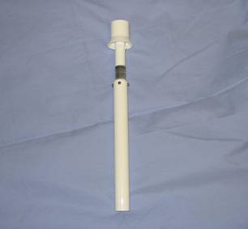
Hyperlink Technologies | Ultra Wide Band Enclosed Log Periodic Antenna | 2.3GHz - 6.5GHz | 50W |  | 0.0889 |  | 0.0332 |  | 0.162 |  | 1.3 | 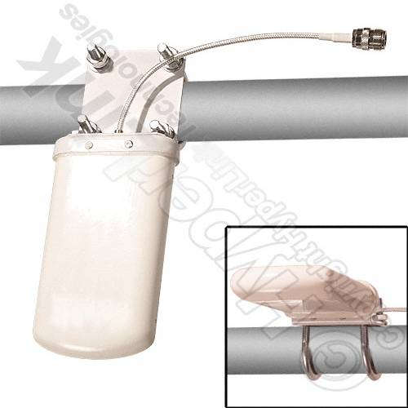
Antennas.US | Broadband Omni Antenna | 3.0GHz - 8.0GHz | 10 W |  | 0.04 |  | 0.04 |  | .11 |  | .5 | 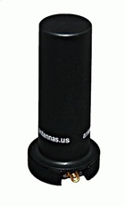
Manufacturer | Description | Bandwidth (GHz) | Input Power (W) |  | Length (m) | Width (m) |  | Height (m) |  | Weight (lbs) |  |  | Picture
Aeroflex | High Power Amplifier module | 2.0 - 18.0 | 36 |  | 0.027 | 0.0162 |  | 0.004 |  | 0.3* |  |  | 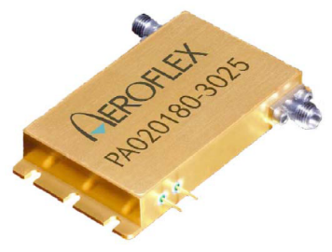
RF Amplifiers.Com | Ultra Wide Band Amplifier | 0.1 - 6.0 | --- |  | 0.02 | 0.015 |  | 0.015 |  | 0.3* |  |  | 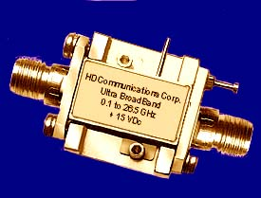
B&Z Technologies | Wideband LNA | 2.0 - 8.0 | 1.425 |  | 0.011 | 0.014 |  | 0.003 |  | 0.3* |  |  | 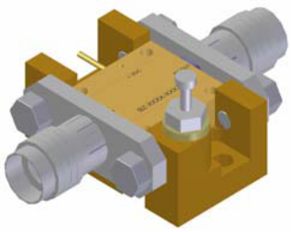

Appendix B – Mechanical Drawings

Appendix C – Performance Plots

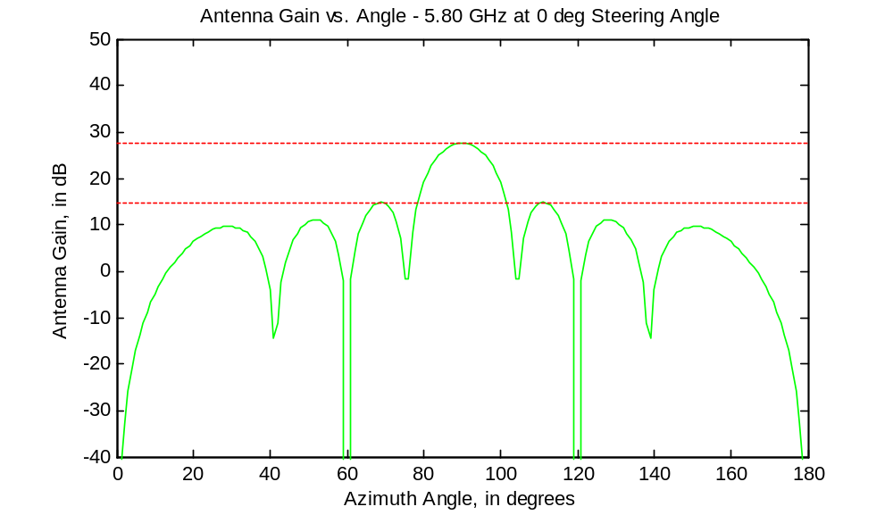

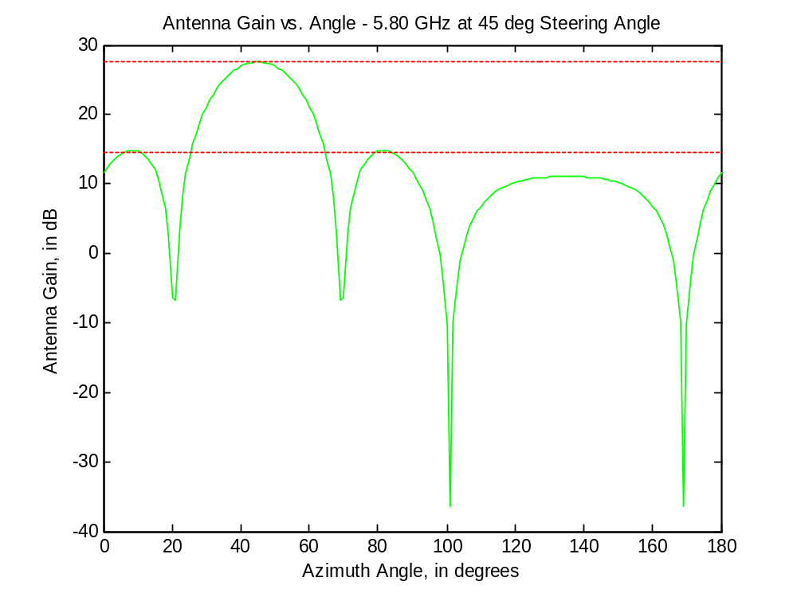
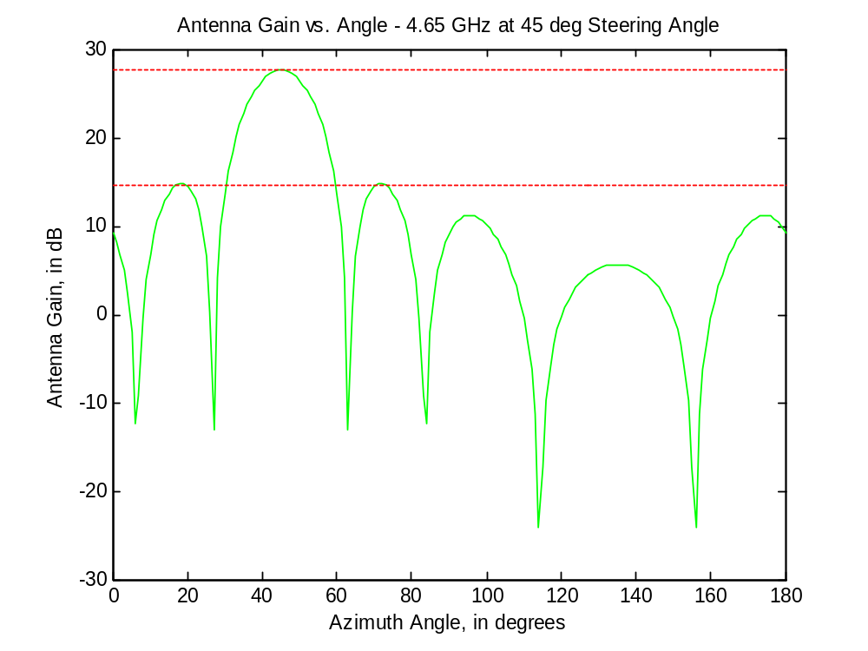
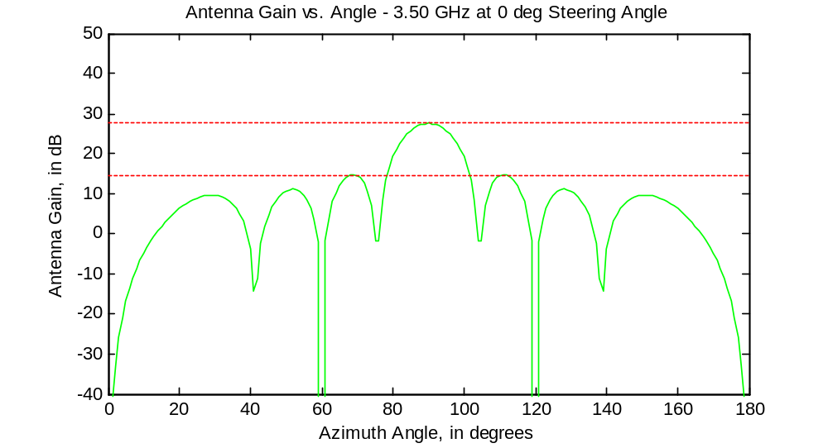
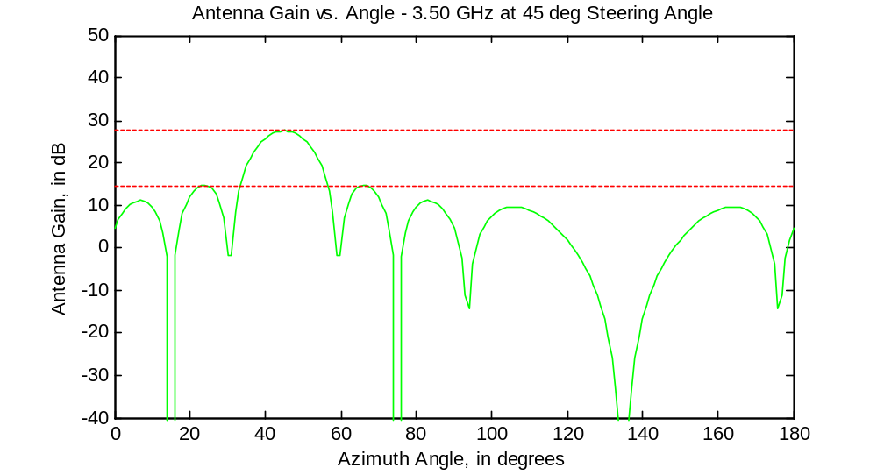

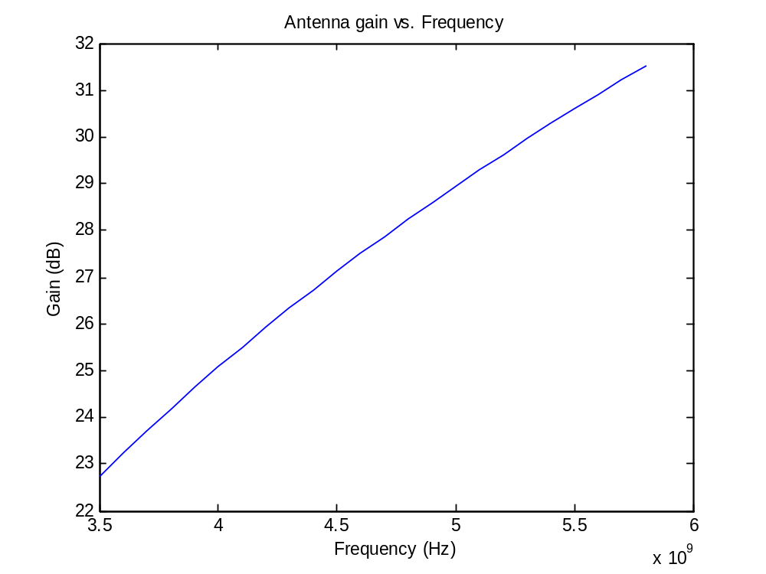 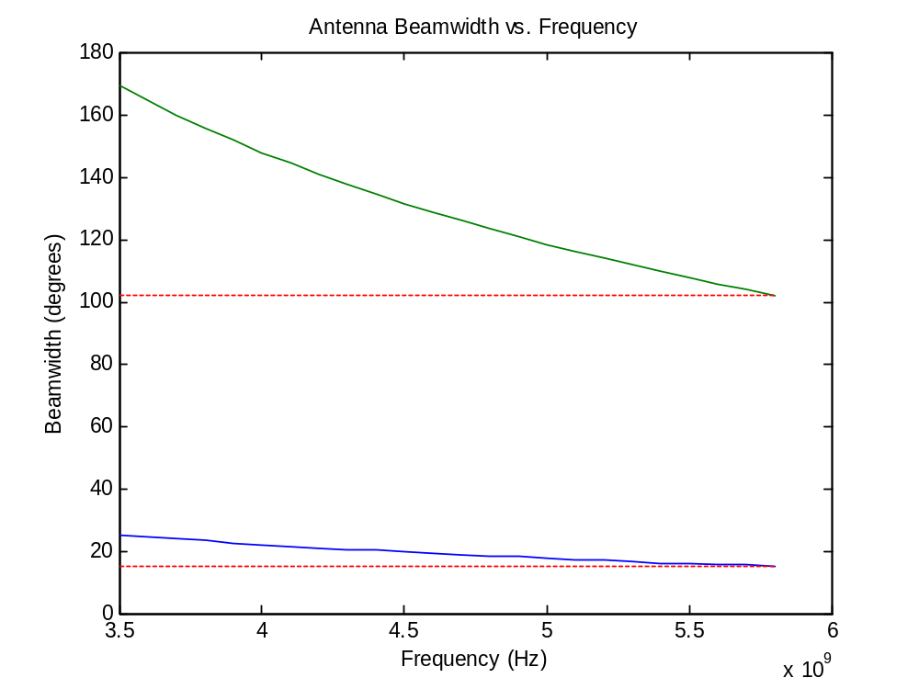 Appendix D – MATLAB Code

close all;
clear all;
%% Define Initial Parameters %%

fprintf('-INPUTS------------------------\n');

% These are the variables we can adjust:
v = 160000/3600; % Velocity in m/s - 160km/h
h = 7500; % Initial height (m) - cruising altitude
ele_wt = .5+.3; % Weight per element (lbs)
ele_pwr = 10+1.425; % Power per element (W)

fprintf('Velocity: %f m/s\n',v);
fprintf('Altitude: %f m\n',h);
fprintf('Weight per Element: %f lbs\n',ele_wt);
fprintf('Power per Element: %f W\n',ele_pwr);

% Define constants:
c = 3e8; % Speed of Light (m/s)
freq_l = 3.5e9; % Lower frequency bound of antenna bandwidth
freq_u = 5.8e9; % Upper frequency bound of antenna bandwidth
freq_m = (freq_l + freq_u)/2; % Middle frequency of antenna bandwidth

lambda_l = c / freq_l; % Wavelength at low freq
lambda_u = c / freq_u; % Wavelength at high freq
lambda_m = c / freq_m; % Wavelength at mid freq

dx = lambda_u/2; % Element Spacing (x)
dy = lambda_u/4; % Element Spacing (y)

%% Define parametric equations based on Initial Parameters %%

fprintf('-OUTPUTS-----------------------\n');

xi = v * 600; % X Position at time t=0 (600 seconds from target)
Ri = sqrt(h^2 + xi^2); % Radial distance from the start point to target
theta_Max = atan(xi/h); % Maximum sweep angle
fprintf('Maximum Sweep Angle: %f degrees\n',theta_Max*180/pi);

% Calculate necessary Beamwidth (BW) at boresight (t = 10 minutes)
Bwx = 2* atan(1000/h); % 1 km band
Bwy = 2* atan(9260/h); % 5 nmi wide
fprintf('Beamwidth: %f x %f degrees\n',Bwx*180/pi, Bwy*180/pi);

% Calculate dimensions of phased antenna array.
Dx = lambda_u / Bwx; % Dx = dx*nx
Dy = lambda_u / Bwy; % Dy = dy*ny
fprintf('Array Size: %f x %f meters\n',Dx,Dy);
fprintf('Element Spacing: %f x %f meters\n',dx,dy);

nx = ceil(Dx / dx); % # of elements in x direction based on dimensions
ny = ceil(Dy / dy); % # of elements in y direction based on dimensions
tot_ele = nx * ny; % Total # of elements in array.
fprintf('Elements: %i x %i = %i\n',nx,ny,tot_ele);

tot_wt = tot_ele * ele_wt; % Total weight of the antenna array.
fprintf('Weight of Elements: %f lbs\n',tot_wt);

tot_pwr = tot_ele * ele_pwr; % Total power of antenna array.
fprintf('Power Consumption: %f W\n',tot_pwr);

% Calculate the total power needed for transmission :
% dBW (Receiver) = dBW (Antenna Gain + HPA) - FreeSpacePathLoss
% ==> Need -85 = -55dBW to be seen at the enemy receiver.

% FSP = 20 * log((4*pi*Ri*freq_u)/c) ~~~ in dB
% ===> Ri = Furthest radial distance (at t = 0)

FSPL = 20 * log10((4*pi*Ri*freq_u)/c);

% Calculate required power given all specifications.
% -55 = dBW seen at receiver

Req_TPwr_dB = -55 + FSPL; % Required dB at trasmitter.
fprintf('Required Tx Power: %f dBW\n',Req_TPwr_dB);

Req_TPwr = 10^((Req_TPwr_dB)/10); % Calculate req. pwr in Watts (W)

ant_gain = 20*log10((4*pi*nx*dx*ny*dy)/(lambda_l^2)); % Gain of antenna array
fprintf('Gain of Antenna: %f dB\n',ant_gain);
hpa_gain = Req_TPwr_dB - ant_gain; % Total Required Amp Gain
fprintf('Total Gain of HPA: %f dB\n',hpa_gain);
fprintf('Single HPA Gain: %f dB\n',hpa_gain/tot_ele);

%% Graph #1 - Lowest Freq @ 0 deg

lambda = lambda_u;

Wtel = ones(1,ny); % weights in elevation
bu = zeros(1,nx); % voltage in dB given to each element
WndBu = 10.^(-0.05.*bu); % voltage in watts
k = 2*pi/lambda; % wave number
phi = 0; % steering angle
%G = 10000 + 30dB %input power

theta=0:pi/180:pi;
for l = 1:nx
Au(l,:) = sum(Wtel)*WndBu(l)*exp((j*k*l*dx).*(cos(theta+ phi)));
end

G = 1;
Au_log = 20*log10(abs(sum(Au)).*sqrt(G));

figure(1);
plot(theta*180/pi,real(Au_log),'g',...
0:180,ones(1,length(theta))*max(real(Au_log)),'r:',...
0:180,ones(1,length(theta))*max(real(Au_log))-13,'r:');
title('Antenna Gain vs. Angle - 5.80 GHz at 0 deg Steering Angle')
xlabel('Azimuth Angle, in degrees')
ylabel('Antenna Gain, in dB');

%% Graph #2 - Lowest Freq @ 45 deg

lambda = lambda_l;

Wtel = ones(1,ny); % weights in elevation
bu = zeros(1,nx); % voltage in dB given to each element
WndBu = 10.^(-0.05.*bu); % voltage in watts
k = 2*pi/lambda; % wave number
phi = deg2rad(45); % steering angle
%G = 10000 + 30dB %input power

theta=0:pi/180:pi;
for l = 1:nx
Au(l,:) = sum(Wtel)*WndBu(l)*exp((j*k*l*dx).*(cos(theta+ phi)));
end

G = 1;
Au_log = 20*log10(abs(sum(Au)).*sqrt(G));

figure(2);
plot(theta*180/pi,real(Au_log),'g',...
0:180,ones(1,length(theta))*max(real(Au_log)),'r:',...
0:180,ones(1,length(theta))*max(real(Au_log))-13,'r:');
title('Antenna Gain vs. Angle - 5.80 GHz at 45 deg Steering Angle')
xlabel('Azimuth Angle, in degrees')
ylabel('Antenna Gain, in dB');

%% Graph #3 - Middle Freq @ 0 deg

lambda = lambda_m;

Wtel = ones(1,ny); % weights in elevation
bu = zeros(1,nx); % voltage in dB given to each element
WndBu = 10.^(-0.05.*bu); % voltage in watts
k = 2*pi/lambda; % wave number
phi = deg2rad(0); % steering angle;
%G = 10000 + 30dB %input power

theta=0:pi/180:pi;
for l = 1:nx
Au(l,:) = sum(Wtel)*WndBu(l)*exp((j*k*l*dx).*(cos(theta+ phi)));
end

G = 1;
Au_log = 20*log10(abs(sum(Au)).*sqrt(G));

figure(3);
plot(theta*180/pi,real(Au_log),'g',...
0:180,ones(1,length(theta))*max(real(Au_log)),'r:',...
0:180,ones(1,length(theta))*max(real(Au_log))-13,'r:');
title('Antenna Gain vs. Angle - 4.65 GHz at 0 deg Steering Angle')
xlabel('Azimuth Angle, in degrees')
ylabel('Antenna Gain, in dB');

%% Graph #4 - Lower Freq @ 45 deg

lambda = lambda_m;

Wtel = ones(1,ny); % weights in elevation
bu = zeros(1,nx); % voltage in dB given to each element
WndBu = 10.^(-0.05.*bu); % voltage in watts
k = 2*pi/lambda; % wave number
phi = deg2rad(45);
%G = 10000 + 30dB %input power

theta=0:pi/180:pi;
for l = 1:nx
Au(l,:) = sum(Wtel)*WndBu(l)*exp((j*k*l*dx).*(cos(theta+ phi)));
end

G = 1;
Au_log = 20*log10(abs(sum(Au)).*sqrt(G));

figure(4);
plot(theta*180/pi,real(Au_log),'g',...
0:180,ones(1,length(theta))*max(real(Au_log)),'r:',...
0:180,ones(1,length(theta))*max(real(Au_log))-13,'r:');
title('Antenna Gain vs. Angle - 4.65 GHz at 45 deg Steering Angle')
xlabel('Azimuth Angle, in degrees')
ylabel('Antenna Gain, in dB');

%% Graph #5 - Highest Freq @ 0 deg

lambda = lambda_u;

Wtel = ones(1,ny); % weights in elevation
bu = zeros(1,nx); % voltage in dB given to each element
WndBu = 10.^(-0.05.*bu); % voltage in watts
k = 2*pi/lambda; % wave number
phi = deg2rad(0); % steering angle
%G = 10000 + 30dB %input power

theta=0:pi/180:pi;
for l = 1:nx
Au(l,:) = sum(Wtel)*WndBu(l)*exp((j*k*l*dx).*(cos(theta+ phi)));
end

G = 1;
Au_log = 20*log10(abs(sum(Au)).*sqrt(G));

figure(5);
plot(theta*180/pi,real(Au_log),'g',...
0:180,ones(1,length(theta))*max(real(Au_log)),'r:',...
0:180,ones(1,length(theta))*max(real(Au_log))-13,'r:');
title('Antenna Gain vs. Angle - 3.50 GHz at 0 deg Steering Angle')
xlabel('Azimuth Angle, in degrees')
ylabel('Antenna Gain, in dB');

%% Graph #6 - Highest Freq @ 45 deg

lambda = lambda_u;

Wtel = ones(1,ny); % weights in elevation
bu = zeros(1,nx); % voltage in dB given to each element
WndBu = 10.^(-0.05.*bu); % voltage in watts
k = 2*pi/lambda; % wave number
phi = deg2rad(45);
%G = 10000 + 30dB %input power

theta=0:pi/180:pi;
for l = 1:nx
Au(l,:) = sum(Wtel)*WndBu(l)*exp((j*k*l*dx).*(cos(theta+ phi)));
end

G = 1;
Au_log = 20*log10(abs(sum(Au)).*sqrt(G));

figure(6);
plot(theta*180/pi,real(Au_log),'g',...
0:180,ones(1,length(theta))*max(real(Au_log)),'r:',...
0:180,ones(1,length(theta))*max(real(Au_log))-13,'r:');
title('Antenna Gain vs. Angle - 3.50 GHz at 45 deg Steering Angle')
xlabel('Azimuth Angle, in degrees')
ylabel('Antenna Gain, in dB');

%% Antenna Gain vs Frequency %%

freqs = [3.5:.1:5.8]*10^9;
lambdas = c./freqs;
Gs = 20*log10(4*pi*nx*dx*ny*dy./lambdas.^2);

figure(7);
plot(freqs,Gs);
title('Antenna gain vs. Frequency');
xlabel('Frequency (Hz)');
ylabel('Gain (dB)');

%% Beamwidth vs Frequency %%

BWxs = (180/pi)*(lambdas./Dx);
BWys = (180/pi)*(lambdas./Dy);

figure(8);
plot(freqs,BWxs,freqs,Bwx*180/pi*ones(1,length(freqs)),'r:',...
freqs,BWys,freqs,Bwy*180/pi*ones(1,length(freqs)),'r:');
title('Antenna Beamwidth vs. Frequency');
xlabel('Frequency (Hz)');
ylabel('Beamwidth (degrees)');

fprintf('\n');

